**The capsaicin receptor: a heat-activated ion channel in the pain pathway**



Michael J. Caterina*, Mark A. Schumacher†k, Makoto Tominaga*k, Tobias A. Rosen*, Jon D. Levine‡ & David Julius*

*Departments of* * *Cellular and Molecular Pharmacology,* † *Anesthesia, and* ‡ *Medicine, University of California, San Francisco, California 94143-0450, USA*

k *These authors contributed equally to this study.*

. ............ ............ ............ ........... ............ ............ ............ ........... ............ ............ ........ .... ........... ............ ............ ............ ........... ............ ............ ............ ............ ...........

**Capsaicin, the main pungent ingredient in ‘hot’ chilli peppers, elicits a sensation of burning pain by selectively activating sensory neurons that convey information about noxious stimuli to the central nervous system. We have used an expression cloning strategy based on calcium influx to isolate a functional cDNA encoding a capsaicin receptor from sensory neurons. This receptor is a non-selective cation channel that is structurally related to members of the TRP family of ion channels. The cloned capsaicin receptor is also activated by increases in temperature in the noxious range, suggesting that it functions as a transducer of painful thermal stimuli** *in vivo***.**

Pain is initiated when the peripheral terminals of a subgroup of sensory neurons are activated by noxious chemical, mechanical or thermal stimuli. These neurons, called nociceptors, transmit infor- mation regarding tissue damage to pain-processing centres in the spinal cord and brain1. Nociceptors are characterized, in part, by their sensitivity to capsaicin, a natural product of capsicum peppers that is the active ingredient of many ‘hot’ and spicy foods. In mammals, exposure of nociceptor terminals to capsaicin leads initially to excitation of the neuron and the consequent perception of pain and local release of inflammatory mediators. With pro- longed exposure, nociceptor terminals become insensitive to cap- saicin, as well as to other noxious stimuli2. This latter phenomenon of nociceptor desensitization underlies the seemingly paradoxical use of capsaicin as an analgesic agent in the treatment of painful disorders ranging from viral and diabetic neuropathies to rheuma- toid arthritis3,4. Some of this decreased sensitivity to noxious stimuli may result from reversible changes in the nociceptor, but the long- term loss of responsiveness can be explained by death of the nociceptor or destruction of its peripheral terminals following exposure to capsaicin2,5.

The cellular specificity of capsaicin action and its ability to evoke the sensation of burning pain have led to speculation that the target of capsaicin action plays an important physiological role in the detection of painful stimuli. Indeed, capsaicin may elicit the perception of pain by mimicking the actions of a physiological stimulus or an endogenous ligand produced during tissue injury6. Although the excitatory and neurotoxic properties of capsaicin have been used extensively to define and study nociceptive neurons, its precise mechanism of action has remained elusive. Electrophysiological7,8 and biochemical9 studies have shown that capsaicin excites nociceptors by increasing the permeability of the plasma membrane to cations, but the molecular mechanism under- lying this phenomenon is unclear. Proposed models range from the direct perturbation of membrane lipids by hydrophobic capsaicin molecules10 to the activation of a specific receptor on or within sensory neurons6. Because capsaicin derivatives show structure– function relationships and evoke responses in a dose-dependent manner11,12, the existence of a receptor site represents the most likely mechanism. This model has been strengthened by the development of capsazepine, a competitive capsaicin antagonist13, and by the discovery of resiniferatoxin, an extremely potent capsaicin analogue from *Euphorbia* plants that mimics the cellular actions of capsaicin14,15. The potency of resiniferatoxin at nanomolar quantities

has led to its use as a high-affinity radioligand to visualize saturable, capsaicin- and capsazepine-sensitive binding sites on nociceptors16. A more detailed understanding of the molecular nature of capsaicin action and its relationship to endogenous pain signalling mechanisms might be obtained through the cloning of a gene encoding a capsaicin receptor. To achieve this we used a functional screening assay to isolate a cDNA clone that reconstitutes capsaicin responsiveness in non-neuronal cells. The deduced amino-acid sequence of this clone demonstrates that the capsaicin receptor is an integral membrane protein with homology to a family of putative store-operated calcium channels. The cloned receptor seems to be

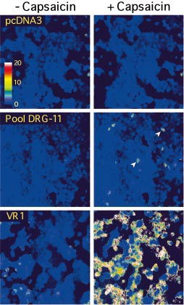

Figure 1 Expression cloning of a capsaicin receptor using calcium imaging. HEK293 cells transiently transfected with pools of clones from a rodent dorsal root ganglion (DRG) cDNA library were subjected to microscopic fluorescent calcium imaging before (left) and during (right) treatment with 3 µM capsaicin. Cells transfected with vector alone (pCDNA3; top) exhibited no response to capsaicin. Between 1% and 5% of cells transfected with pool 11 exhibited marked increases in cytoplasmic calcium (middle, arrowheads). This pool was iteratively subdivided and reassayed until a single positive clone (VR1) was isolated (bottom). Elevated relative calcium concentrations are indicated by an increased ratio of Fura-2 emission at 340 versus 380 nm wavelength excitation (see colour bar).

expressed exclusively by small-diameter neurons within sensory ganglia, providing a definitive molecular explanation for the remarkable selectivity of capsaicin action. This receptor is also a thermal sensor that is strongly activated when ambient tempera- tures are elevated to a range known to elicit pain in humans or pain- associated behaviours in animals. Thus capsaicin elicits burning sensations through the activation of a heat-gated ion channel that is likely to contribute to the detection of painful thermal stimuli *in vivo*.



**Expression cloning of receptor cDNA**

The lack of specific information regarding the molecular structure of capsaicin receptors prompted us to adopt a functional screening strategy for isolating candidate cDNA clones. A mammalian cell expression cloning strategy was devised on the basis of the ability of capsaicin to trigger robust calcium influx into sensory neurons *in vitro*9,17. We reasoned that a capsaicin receptor-encoding cDNA might confer upon non-neuronal cells a similar ability to undergo increases in intracellular free calcium upon exposure to capsaicin, assuming that capsaicin acts at a proteinaceous site and that a single cDNA can confer sensitivity to capsaicin in a heterologous context. Because capsaicin responsiveness seems to be confined to nocicep- tive neurons with cell bodies that reside within sensory ganglia5, a cDNA library was constructed from dorsal root ganglion-derived messenger RNA. This library was subdivided into pools of approxi- mately 16,000 clones, and each pool was transiently transfected into human embryonic kidney-derived HEK293 cells. Transfected cells were then loaded with the fluorescent calcium-sensitive dye Fura-2

(ref. 18), and microscopically examined for capsaicin-evoked changes in intracellular calcium levels. A positive pool was identified (Fig. 1, middle) and iteratively subdivided and reassayed. In this way, an individual clone containing a 3-kilobase (kb) cDNA insert was obtained that, by itself, conferred capsaicin (Fig. 1, bottom) or resiniferatoxin (not shown) sensitivity to transfected HEK293 cells. Because a vanilloid moiety constitutes an essential chemical com- ponent of capsaicin and resiniferatoxin structures, the proposed site of action of these compounds is more generally referred to as the vanilloid receptor16. Accordingly, we have named the newly cloned cDNA VR1, for vanilloid receptor subtype 1.

**VR1 and vanilloid receptor pharmacology**

To compare the pharmacological properties of the cloned receptor to those of native vanilloid sites in sensory ganglia, we expressed VR1 in *Xenopus* oocytes and used whole-cell voltage-clamp analysis to quantitatively examine the electrophysiological responses to a variety of vanilloid agonists and antagonists. At negative holding potentials, exposure to capsaicin or resiniferatoxin produced dose- dependent inward current responses in VR1-expressing oocytes, but not in water-injected control cells (Fig. 2a). As observed in sensory neurons19,20, capsaicin-evoked current responses returned rapidly to baseline after agonist removal, whereas resiniferatoxin responses often failed to recover, even after a prolonged washout period. Half-maximal effective concentrations for these agonists were within an order of magnitude of those reported for native vanilloid receptors8,13, with resiniferatoxin being approximately 20- fold more potent than capsaicin (EC50 ¼ 39:1 nM and 711.9 nM,

**a**

capsaicin (1 M)

**b**

resiniferatoxin (0.1 M)

20 s

200 nA

100

80

% Maximal response

60

40

20

0

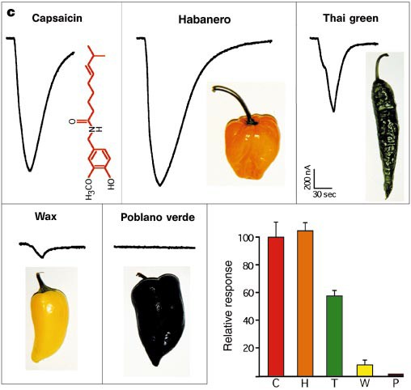-9 -8 -7 -6 -5

Agonist (log M)

cap cap + cpz

20 s

cap

100

% Capsaicin response

80

60

cap

20 s

100 nA

cap + RR

cap

40

400 nA

20

0

-9 -8 -7 -6 -5 -4

Capsazepine (log M)

Figure 2 VR1 responds to purified vanilloids and pepper extracts. a, Activation of VR1 by capsaicin and resinferatoxin. Left, agonists were applied sequentially to the same *Xenopus* oocyte expressing VR1. Membrane currents were recorded in the whole-cell voltage-clamp configuration. Bars denote duration of agonist application. Right, concentration–response curve for capsaicin (filled squares) and resiniferatoxin (open circles). Membrane currents were normalized in each oocyte to a response obtained with 1 µM capsaicin and expressed as a percent of

maximal response to capsaicin. Each point represents mean values (士s.e.m.)

from five independent oocytes. The Hill equation was used to fit the response data. b, Antagonism by capsazepine (cpz) and ruthenium red (RR). Current tracing at top left shows reversible block of capsaicin (cap; 0.6 µM) response by capsazepine (cpz; 10 µM) after 2 min pretreatment. Slash marks represent washout periods of 2 and 3 min, respectively (*n* ¼ 3). A capsazepine inhibition

curve is shown to the right (*n* ¼ 4 independent oocytes for each point). Current responses were normalized to that elicited by capsaicin alone in each oocyte. (0.6 µM, open diamond). Current tracing at bottom left shows reversible block of a capsaicin (0.6 µM)-evoked response by ruthenium red (RR; 10 µM). Slash marks denote washout periods of 2 and 12 min, respectively (*n* ¼ 3). c, Responses to capsaicin (10 µM) and extracts derived from four varieties of peppers in oocytes expressing VR1 (30 s application). Bottom right, relative potencies of each pepper extract are plotted (mean 士s:e:m:, *n* ¼ 3). Values were normalized in each cell to responses obtained with capsaicin (10 µM). Extracts evoked no responses in water-injected cells. Reported pungencies for pepper varieties (in Scoville units) are: Habanero (H), 100,000–300,000; Thai green (T), 50,000–100,000; wax (W), 5,000–10,000; and Poblano verde (P),1,000–1,500 (ref. 23). Capsaicin (C) is rated as 16 x 106 units.

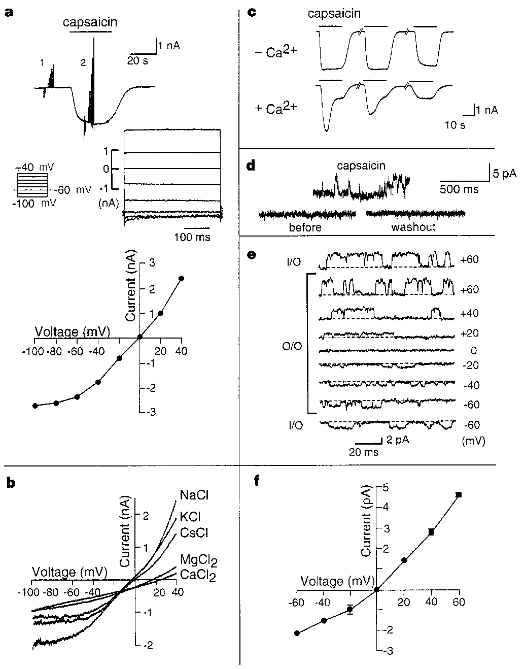

Figure 3 VR1 is a calcium-permeable, non-selective cation channel. Electro- physiological properties of capsaicin-activated currents in VR1-transfected mammalian HEK293 cells. a, VR1 currents are time independent, outwardly rectifying, and cation specific. A capsaicin-evoked inward current response (top) was analysed using a series of 400-ms step pulses (100 to +40 mV; middle, left). Baseline currents (denoted as 1 on top trace) were subtracted from responses in the presence of agonist (2) to yield a series of agonist-evoked responses at different holding potentials (middle, right). These responses show outward rectification when plotted as a function of membrane voltage (bottom). Calcium- free standard bath solution and a caesium aspartate-filled recording electrode were used. b, Capsaicin elicits non-selective cation currents in VR1-transfected cells. Voltage ramps (100 to +40 mV in 500 ms) were used to generate current– voltage curves in bath solutions with the indicated cationic compositions. Recording electrodes were filled with NaCl. Similar results were obtained with KCl- or CsCl-filled electrodes. Replacement of extracellular NaCl (140 mM) with equimolar KCl or CsCl did not significantly shift reversal potential (*E*rev ¼



— 0:7 士 1:2 mV, *n* ¼ 8; — 1:5 士 1:0 mV, *n* ¼ 9; — 4:3 士 0:9 mV, *n* ¼ 8, respectively;

*P*K=*P*Na ¼ 0:94; *P*Ca=*P*Na ¼ 0:85). Replacement of extracellular NaCl with isotonic (112 mM) MgCl2 or CaCl2 shifted *E*rev to 14:4 士 0:7 mV (*n* ¼ 5) or 24:3 士 2:3 mV (*n* ¼ 7), respectively (*P*Mg=*P*Na ¼ 4:99; *P*Ca=*P*Na ¼ 9:60). c, Whole-cell current responses evoked by repeated capsaicin applications show desensitization in calcium-containing standard bath solution, but not in calcium-free solution. Capsaicin (1 µM) was applied every 5 min and CsCl was used as pipette solution. The ratios of current size at the end of the third application to the peak of the first application were 95:3 士 2:6% (*n* ¼ 3) in calcium-free solution, and 13:0 士 4:3% (*n* ¼ 5) in calcium-containing solution (*t*-test; *P* < 0:00001). d–f, Single-channel properties of capsaicin-evoked responses. Inside-out (I/O) or outside-out (O/O) patches were excised from VR1-transfected cells and analysed in symmetrical 140 mM NaCl. d, Traces obtained from a single O/O patch before, during and after capsaicin (1 µM) application to the bath solution (*V*hold ¼ þ40 mV). Note multiple simultaneous channel openings in the presence of capsaicin. e, Traces obtained in the presence of capsaicin at the indicated holding potentials. Broken lines indicate the closed-channel level. No agonist-evoked channel activity was seen in cells transfected with vector alone (*n* ¼ 8, not shown). f, Current–voltage curve of mean single-channel amplitudes (士s.e.m.) calculated from data shown in e, also exhibits pronounced outward rectification.

respectively). Hill coefficients derived from these analyses (1.95 and 2.08, respectively) suggest that full activation of the receptor involves the binding of more than one agonist molecule, again consistent with previously described properties of native vanilloid receptors8,16. Capsaicin-evoked responses in VR1-expressing oocytes were reversibly blocked by the competitive vanilloid recep- tor antagonist capsazepine at concentrations (IC50 ¼ 283:5 nM) that inhibit native receptors13 (Fig. 2b). Another pharmacological characteristic of vanilloid receptors, is their sensitivity to the non- competitive antagonist ruthenium red17, which blocked capsaicin- evoked responses in a reversible manner (Fig. 2b). Responses to resiniferatoxin (50 nM) were also reversibly antagonized by capsa- zepine (5 µM) or ruthenium red (10 µM) (not shown).

As has been recognized for years, the relative pungencies of pepper varieties span an enormously wide range, reflecting, in part, differences in vanilloid content. Methods for rating peppers with respect to their relative ‘hotness’ have hitherto relied on subjective psychophysical assays21 or on the biochemical determi- nation of capsaicin content22. To further explore the connection between the biology and biochemistry of vanilloid action, we sought to determine whether the cloned vanilloid receptor could respond electrophysiologically to pepper extracts in proportion to their ability to evoke pain. Ethanol extracts were prepared from several capsicum varieties and their potencies relative to a saturating dose of capsaicin (10 µM) were determined in the oocyte expression system (Fig. 2c). Indeed, we found that the different ‘hotness’ of these pepper variants, as determined by subjective psychophysical ratings23, correlated with their rank order potencies as activators of VR1.

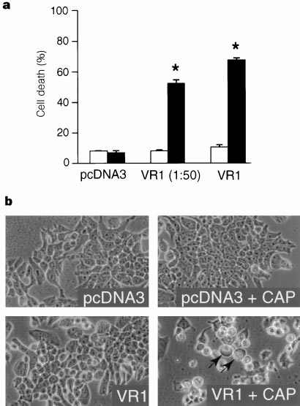

Figure 4 Capsaicin induces death of cells expressing the vanilloid receptor. a, HEK293 cells were transiently transfected with either vector alone (pCDNA3), VR1 cDNA diluted 1 : 50 in pCDNA3, or VR1 cDNA alone. After 7 h at 37 °C in the presence of capsaicin (3 µM, black bars) or vehicle (0.3% ethanol, white bars), the percentage of dead cells was determined. Data represent mean 士 s:e:m: of triplicate determinations from a representative experiment. Asterisks indicate a significant difference from ethanol-treated cells (*t*-test, *P* < 0:0001). b, Phase- contrast photomicrographs of parallel cultures transfected with pCDNA3 or VR1 (1 : 50) before (left) or 4 h after (right, +CAP) addition of capsaicin (3 µM). Note the cytoplasmic swelling and eccentric position of cytoplasmic contents (arrows).

**818**

**Nature © Macmillan Publishers Ltd 1997**

NATURE | VOL 389 | 23 OCTOBER 1997

To explore the possibility that capsaicin mimics the action of a known chemical modulator of nociceptor function, we tested agents known to activate sensory neurons for their ability to evoke responses in HEK293 cells or oocytes expressing VR1. None of the agents tested gave positive responses, including adenosine tripho- sphate (50 µM), serotonin (10 µM), acetylcholine (300 µM), bradykinin (1 µM), substance P (10 µM), histamine (10 µM), glutamate (100 µM), and hypertonic saline (600 mOsm).



**VR1 ion channel has high Ca2+ permeability**

To characterize more fully the electrophysiological properties of the cloned receptor at both whole-cell and single-channel levels, we performed a series of patch-clamp studies on transfected mamma- lian cells expressing VR1. In the whole-cell configuration, VR1- transfected HEK293 cells showed robust inward current responses (at a holding potential of 60 mV) that developed with a short latency upon bath application of capsaicin (Fig. 3a). No such currents were observed in cells transfected with vector alone (not shown). In calcium-free medium, the capsaicin-evoked current did not vary with time, either at a constant holding potential of 60 mV or during voltage steps from 100 to +40 mV (in increments of 20 mV) (Fig. 3a). This property enabled us to characterize capsaicin- mediated currents under steady-state response conditions in sub- sequent experiments. Current–voltage relations derived from these data show that such responses exhibit prominent outward rectifica- tion resembling that observed in cultured dorsal root ganglion neurons8 (Fig. 3a, bottom). Because the observed reversal potential was close to 0 mV (*E*rev ¼ 0:5 士 0:9 mV, *n* ¼ 13), the capsaicin- mediated response must involve the opening of a cation-selective channel. In sensory neurons, vanilloid-evoked currents are carried by a mixture of monovalent and divalent cations7–9, and we there- fore conducted a series of ion substitution experiments to examine the relative contributions of various cations to capsaicin-evoked

currents in VR1-expressing cells. Current–voltage relations estab- lished for cells bathed in solutions of differing cationic composi- tions show that VR1 does not discriminate among monovalent cations, but exhibits a notable preference for divalent cations (permeability sequence: Ca2þ > Mg2þ > Naþ = Kþ = Csþ) (Fig. 3b). The very high relative permeability of VR1 to calcium ions (*P*Ca=*P*Na ¼ 9:60; *P*Mg=*P*Na ¼ 4:99) exceeds that observed for most non-selective cation channels, and is similar to values reported for NMDA-type glutamate receptors and *a*7 nicotinic acetylcholine receptors (*P*Ca=*P*Na ¼ 10:6 and 20, respectively)24,25, both of which are noted for this property. With all bath solutions examined, an outwardly rectifying current–voltage relation was observed, although this feature was less prominent in bath solutions contain- ing MgCl2 or CaCl2.

In cultured sensory neurons, electrophysiological analyses of vanilloid-evoked responses have shown them to be kinetically complex and to desensitize with continuous vanilloid exposure20,26. This electrophysiological desensitization (which might underlie aspects of physiological desensitization produced by vanilloids *in vivo*) seems to depend, in part, on the presence of extracellular calcium26,27. Indeed, in the absence of extracellular calcium, capsai- cin-evoked responses in VR1-transfected cells showed little or no desensitization during prolonged agonist application or with suc- cessive agonist challenges (4:7 士 2:3% decrease between first and third applications, *n* ¼ 3 (Fig. 3c)). In contrast, responses evoked in calcium-containing bath solution consisted of at least two distinct components, one desensitizing (87 士 4:3% decrease between first and third applications, *n* ¼ 5) and one relatively non-desensitizing. Thus desensitization and multiphasic kinetics of vanilloid-evoked responses can be reproduced without a neuronal context and can be distinguished by their dependence on ambient calcium levels.

The behaviour of the VR1 response was also examined in membrane patches excised from transfected cells. In the presence

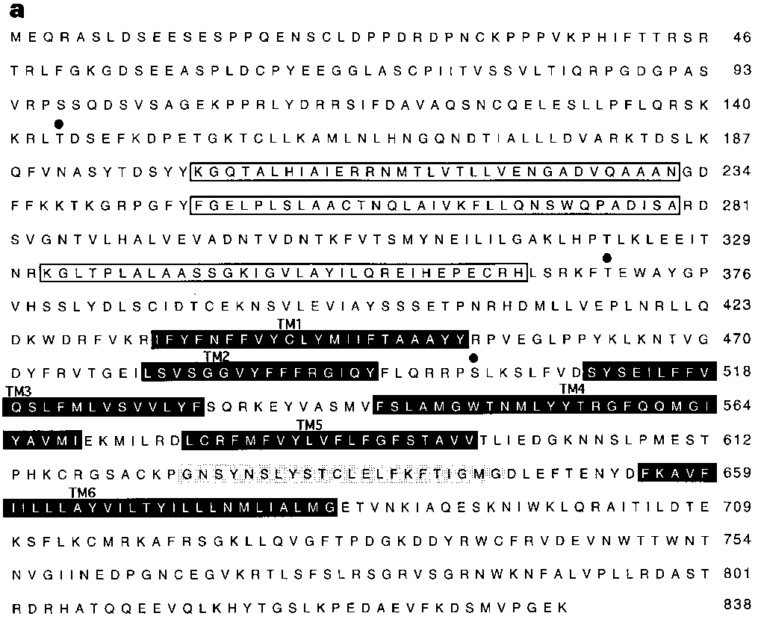Figure 5 VR1 resembles store-operated channels. a, Predicted amino-acid sequence encoded by the vanilloid receptor cDNA VR1. Open boxes delineate ankyrin repeat domains, black boxes predicted transmembrane domains, the grey box a possible pore-loop, and filled circles predicted protein kinase A phosphorylation sites. b, Predicted membrane topology and domain structure of VR1. Outer (o) and inner (i) plasma membrane leaflets are indicated. c, Alignment of VR1 with related sequences. Identical residues are in black boxes and conservative substitutions are in grey. A partial sequence from a human EST is shown. Other sequences are from members of the putative store-operated calcium channel family. The Genbank accession number of the *Drosophila* TRP protein is p19334; others are indicated.

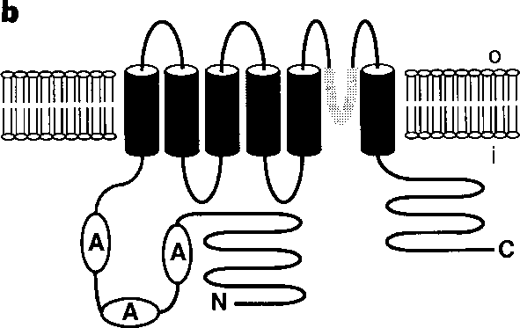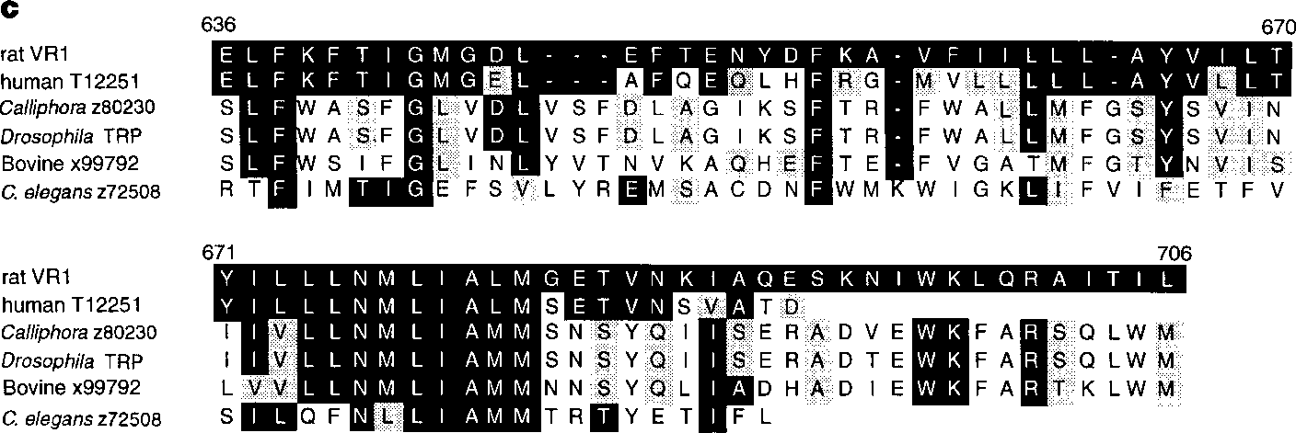

of capsaicin (but not its absence), large and well-resolved currents of unitary amplitude were observed (*n* ¼ 31; Fig. 3d, e), indicating the existence of capsaicin-gated ion channels within these patches whose activation does not depend upon soluble cytoplasmic com- ponents. The current–voltage relation at the single-channel level was almost identical to that established in whole-cell configuration, owing to its outward rectification and reversal potential near 0 mV under similar ionic conditions (Fig. 3f). Unitary conductances of



76.7 pS at positive potentials and 35.4 pS at negative potentials were observed with sodium as the sole charge carrier. These single- channel properties are like those previously described for native vanilloid receptors8,28. It has been suggested that the site of vanilloid action may not be confined to the extracellular side of the plasma membrane, owing to the lipophilic nature of these compounds6. We found that capsaicin was able to produce identical responses when added to either side of a patch excised from a cell expressing VR1 (Fig. 3e), consistent with the notion that vanilloids can permeate or cross the lipid bilayer to mediate their effects. A less likely but formally consistent explanation is that vanilloid receptors have functionally equivalent capsaicin-binding sites on both sides of the plasma membrane.

**Capsaicin kills cells that express VR1**

Capsaicin is an excitatory neurotoxin that selectively destroys primary afferent nociceptors *in vivo* and *in vitro*5,9. Is this selective toxicity solely a reflection of the specificity of vanilloid receptor expression, or does it depend on additional properties of sensory neurons or their environment? To address this question, we sought to determine whether capsaicin could kill non-neuronal cells that express vanilloid receptors *in vitro*. We found that, within several hours of continuous exposure to capsaicin, HEK293 cells trans- fected with VR1 died, as determined morphologically and by staining with vital dyes (Fig. 4). In contrast, cells transfected with

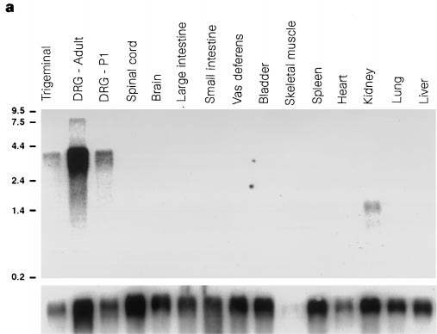

Figure 6 Vanilloid receptor expression is restricted to sensory neurons. a, Northern blot analysis shows that VR1 transcripts are confined to sensory ganglia. Poly(A)+ RNAs were prepared from adult rats, except for the DRG-P1 sample, which was isolated from dorsal root ganglia of newborn pups. The blot was probed with 32P-labelled VR1 cDNA, then re-probed with a 32P-labelled cyclophilin cDNA to control for loading (bottom). Molecular size markers

vector alone were not killed by this treatment. The cell death was characterized by prominent cytoplasmic swelling, coalescence of cytoplasmic contents, and eventual lysis. Thus VR1 expression in a non-neuronal context can recapitulate the cytotoxicity observed in vanilloid-treated sensory neurons. Staining with Hoechst dye 33342 revealed no evidence of the nuclear fragmentation often associated with apoptotic cell death29 (not shown). Together, these observa- tions are consistent with necrotic cell death resulting from excessive ion influx, as has been proposed for vanilloid-induced death of nociceptors7, glutamate-induced excitotoxicity30, and neuro- degeneration caused by constitutively activating mutations of various ion channels31.

**VR1 resembles TRP-related ion channels**

The VR1 cDNA contains an open reading frame of 2,514 nucleo- tides that encodes a protein of 838 amino acids with a predicted relative molecular mass of 95,000 (*M*r 95K) (Fig. 5a). Hydrophilicity analysis suggests that VR1 is a polytopic protein containing six transmembrane domains (predicted to be mostly [3-sheet) with an additional short hydrophobic stretch between transmembrane regions 5 and 6 (Fig. 5b). The amino-terminal hydrophilic segment (432 amino acids) contains a relatively proline-rich region followed by three ankyrin repeat domains. The carboxy terminus (154 amino acids) contains no recognizable motifs.

A homology search of protein databases revealed significant similarities between VR1 and members of the family of putative store-operated calcium channels (SOCs), the prototypical members of which include the *Drosophila* retinal proteins TRP and TRPL32,33 (Fig. 5c). Members of this family have been proposed to mediate the entry of extracellular calcium into cells in response to the depletion of intracellular calcium stores34. These proteins resemble VR1 with respect to their predicted topological organization and the presence of multiple N-terminal ankyrin repeats33. There is also striking

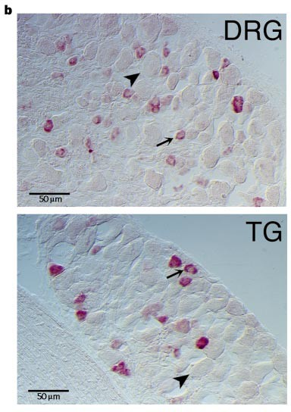

(kilobases) are shown on the left. b, *In situ* hybridization detects VR1 expression in a subset of sensory ganglion cells. Adult rat dorsal root ganglia (DRG) and trigeminal ganglia (TG) were probed with a digoxigenin-labelled, VR1-derived antisense riboprobe. Positive staining (purple) was confined to smaller-diameter cell bodies (arrows) and absent from large-diameter cell bodies (arrowheads). Control (sense) riboprobes did not stain these tissues (not shown).

amino-acid sequence similarity between VR1 and TRP-related proteins within and adjacent to the sixth transmembrane region, including the short hydrophobic region between transmembrane domains 5 and 6 that may contribute to the ion permeation path33. Outside these regions, VR1 shares little sequence similarity with TRP family members, suggesting that its evolutionary relationship to these proteins is distant. Given the high permeability of VR1 to calcium ions, we nonetheless considered the possibility that it might function as a SOC. To test this, we examined calcium-dependent inward currents in VR1-expressing oocytes whose intracellular calcium stores had been depleted by treatment with the compound thapsigargin. In water-injected control oocytes, a clear depletion- induced current was seen, as previously described35 (not shown). In VR1-expressing oocytes, no quantitative or qualitative differences were observed in this response (not shown). Moreover, application of SKF 96365 (20 µM), an inhibitor of depletion-stimulated cal- cium entry36, had no effect on capsaicin-evoked currents in VR1- expressing oocytes (not shown). Thus VR1 does not seem to be a functional SOC under these circumstances.



An expressed sequence tag (EST) database homology search

revealed several human clones with a high degree of similarity to VR1 at both the nucleotide and predicted amino-acid levels. The similarity of one of these clones to the corresponding region of VR1 (Fig. 5c) is extremely high (68% amino-acid identity and 84% similarity within the region shown), suggesting that it is likely to be the human VR1 orthologue or a closely related subtype. Human EST clones corresponding to other domains of VR1 show compar- able degrees of similarity (not shown), and could represent frag- ments of the same human transcript.

**Sensory neuron-specific expression of VR1**

The highly selective nature of capsaicin action suggests that vanil- loid receptors serve as specific molecular markers for nociceptive neurons. Indeed, northern blot analysis showed that a mRNA species of approximately 4 kb is prominently and exclusively

expressed in trigeminal and dorsal root sensory ganglia, both of which contain capsaicin-sensitive neurons (Fig. 6a). This transcript was absent from all other tissues examined, including spinal cord and brain. A much smaller RNA species (~1.5 kb) was detected in the kidney, but it is unclear whether this transcript could encode a functional VR1 protein. *In situ* hybridization histochemistry was used to assess the cellular pattern of VR1 expression within sensory ganglia (Fig. 6b). These experiments clearly show that within dorsal root and trigeminal ganglia, VR1 expression predominates in a subset of neurons with small diameters. This is in keeping with the observation that most capsaicin-sensitive neurons have cell bodies of relatively small to medium size5,27. In contrast to the prominent expression of VR1 transcripts in neurons of the dorsal root gang- lion, no visible signal was observed in the adjacent spinal cord dorsal horn (not shown). Although binding sites for radiolabelled resini- feratoxin have been detected in the dorsal horn, they are believed to reside on presynaptic terminals that project from primary nocicep- tors with cell bodies located in the dorsal root ganglia27. Our results support this interpretation. Two other tissues that have been proposed to express capsaicin receptors are the nodose ganglion, which contains cell bodies of visceral nociceptors27, and the preoptic area of the hypothalamus2, which is involved in thermoregulation37. By using *in situ* hybridization methods, we did not detect VR1 expression at either location. Although these tissues might express VR1 at levels below the detection limit of our assay, vanilloid responsiveness here might be conferred by distinct VR subtypes. Indeed, VR heterogeneity has been proposed on the basis of biochemical studies4,16.

**Vanilloid receptor activated by noxious heat**

The ‘burning’ quality of vanilloid-induced pain suggests that vanilloids and heat may evoke painful responses through a common molecular pathway. We therefore explored the effects of elevated temperature on VR1 activity. In initial studies, transfected HEK293 cells were subjected to fluorescent calcium imaging during

**b**

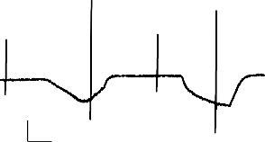

10 s

1 nA

**c**

2,000

Current (nA)

1,500

1,000

500

0

heat capsaicin

**d**

*

VR1

water

VR1

cap heat heat + RR

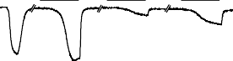

water

heat capsaicin

heat

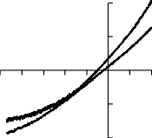

2

1

Voltage (mV)

-100 -80 -60 -40 20 40

-1

h

c

-2

Current (nA)

Figure 7 VR1 is activated by noxious thermal stimuli. a, HEK293 cells transiently transfected with VR1, but not vector alone (pcDNA3), exhibit a pronounced increase in cytoplasmic free calcium in response to heat. Cells were analysed before and immediately after addition of heated buffer (300 µl CIB at 65 °C was applied to cells in 150µl CIB at 22 °C). Under these conditions, cells were transiently exposed to a peak temperature of ~45 °C. Relative calcium concentrations are indicated by the colour bar, as in Fig. 1. b, Whole-cell patch- clamp analysis (*V*hold ¼ — 60 mV) of VR1-transfected HEK293 cells reveals inward current responses to both heat and capsaicin. The temperature of the bath medium was raised from 22 to 48 °C (heat), and then restored to 22 °C, after which capsaicin (0.5 µM) was added to the bath (left trace). Ionic conditions were identical to those described in Fig. 3a. Voltage ramps (100 to +40 mV in 500 ms) were applied before, between and during responses. Stimulus-induced current– voltage relations are shown on the right. c, VR1 expressed in *Xenopus* oocytes is activated by noxious but not innocuous heat. Oocytes injected with either VR1 cRNA or water were subjected to two-electrode voltage-clamp while the perfu- sate temperature was raised from 22.7 °C to the level indicated, then held constant for 60 s. The magnitudes of the resulting inward currents are shown as the mean 士s:e:m: (VR1, *n* ¼ 8; water, *n* ¼ 6 independent cells). The asterisk indicates a significant difference from water-injected oocytes (*t*-test, *P* < 0:0005). d, Ruthe- nium red (RR) inhibits heat-evoked responses in VR1-expressing oocytes. The current tracings shown were generated from representative VR1- or water- injected oocytes during successive applications of the indicated stimuli. VR1- injected oocytes exhibited the following mean inward current responses 士s.e.m.

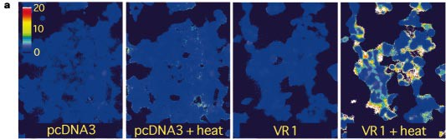(*n* ¼ 5): capsaicin (cap, 1 µM), 1;221 士 148 nA; heat (50 °C), 2;009 士 134 nA; heat

plus RR (10 µM), 243 士 47 nA. Inhibition by RR was significant (88 士 2%, *n* ¼ 5;

20 30 40 50

Temperature (oC)

cap heat heat + RR

40 s

1 A

paired *t*-test, *P* < 0:0001). In the absence of RR, no diminution in current was

observed with successive heat pulses (not shown). Water-injected oocytes showed no response to capsaicin and much smaller responses to heat (338 士 101 nA, *n* ¼ 5). RR inhibited these responses by only 21 士 26% (*n* ¼ 5; paired *t*-test, *P* < 0:1).

a sudden increase in ambient temperature from 22 °C to ~45 °C. Under these conditions, cells transfected with vector alone exhibited only a mild, diffuse change in cytoplasmic free calcium (Fig. 7a, left). In contrast, a large proportion of cells expressing VR1 exhibited a pronounced increase in calcium levels within seconds of heat treatment (Fig. 7a, right). These responses subsided within a few minutes, and a subsequent challenge with capsaicin produced a characteristic calcium response (not shown), suggesting that the response to heat is a specific signalling event and not a consequence of nonspecific membrane perturbation or disruption of cell integ- rity. To determine whether specific heat-evoked membrane currents are associated with this phenomenon, VR1-expressing cells were examined using patch-clamp methods. Exposure of these cells to a rapid increase in temperature (22 °C to ~48 °C in 25 s, monitored using an in-bath thermistor) produced large inward currents (791 士 235 pA at 60 mV, *n* ¼ 9) that were typically similar in amplitude to that evoked by a subsequent application of capsaicin at 500 nM (Fig. 7b). Both heat- and vanilloid-evoked responses showed outward rectification, suggesting that they are mediated by the same entity (Fig. 7b). By comparison, thermally evoked responses of control, vector-transfected cells were much smaller (131 士 23 pA, *n* ¼ 8) and exhibited no rectification (not shown). The heat response in VR1-transfected cells desensitized during stimulus application, whereas that observed in vector-transfected cells did not. These results suggest that VR1 is acting as a thermal transducer, either by itself or in conjunction with other cellular components.



To determine whether VR1 could mediate similar responses to heat in a different cellular environment, we extended these studies to the oocyte system. In control, water-injected oocytes, acute elevation of perfusate temperature produced a small inward current that increased linearly up to 50 °C (Fig. 7c). VR1-expressing oocytes exhibited similar responses at temperatures up to 40 °C, but above this threshold their responses were significantly larger than those of controls. Thus, even in this non-mammalian context, VR1 expres- sion confers heat sensitivity with a temperature–response profile that is remarkably consistent with that reported for thermal nociceptors1. Pharmacological experiments also suggest that VR1 is involved directly in this thermal response: application of ruthe- nium red reduced significantly (88 士 2%, *n* ¼ 5) the response of

**a b**

   cap

   cap

0

VR1-expressing oocytes to heat, whereas the smaller response seen in control cells was reduced by only 21 士 26% (*n* ¼ 5; Fig. 7d). Taken together, these observations strongly support the hypothesis that VR1 is activated by noxious, but not innocuous, heat.

**Protons may be endogenous modulators of VR1**

A reduction in tissue pH resulting from infection, inflammation or ischaemia can produce pain in mammals. It has therefore been proposed that protons might act as endogenous activators or modulators of vanilloid receptors38–40. To address this possibility, we examined the effects of hydrogen ions on the cloned vanilloid receptor using the oocyte expression system. We investigated whether an abrupt reduction in bath solution pH, from 7.6 to 5.5, was sufficient to activate VR1 in the absence of capsaicin. Fewer than 10% of VR1-expressing oocytes treated in this way exhibited a large inward current (not shown), suggesting that hydrogen ions alone cannot efficiently activate this protein. We next assessed the effect of reduced pH on the responsiveness of VR1 to capsaicin. VR1-expressing oocytes were treated with a submaximal concen- tration of capsaicin (300 nM) at pH 7.6 (Fig. 8). Once their current responses reached a relatively stable plateau, the oocytes were exposed to a solution containing the same concentration of capsai- cin at pH 6.3. Under these conditions, the inward current rapidly increased to a new plateau up to fivefold greater in magnitude than the first. Upon returning to pH 7.6, the oocyte response subsided to its initial plateau, and upon the removal of capsaicin it returned to baseline. This potentiation was seen only with subsaturating con- centrations of agonist, as reduced pH did not augment responses to 10 µM capsaicin (not shown). These results suggest that, although hydrogen ions alone are not sufficient to activate VR1, they can markedly potentiate capsaicin-evoked responses, presumably by increasing capsaicin potency.

**Discussion**

Opioids and vanilloids are natural products whose physiological effects are apparently so seductive or desirable that their use has permeated diverse cultures for thousands of years. Consequently, it has long been assumed that their molecular modes of action must involve important physiological processes that underlie endogenous mechanisms of pain sensation and regulation. In the study of opioid action, this assumption led to the discovery of the principal signalling system that suppresses pain *in vivo*41. We expected that the identification of the biological target of vanilloid action would similarly illuminate a fundamental mechanism of pain production. By pursuing this hypothesis, we have defined a molecular compo- nent of the nociceptive pathway that transduces two of the principal

pH 7.6 pH 7.6

pH 6.3

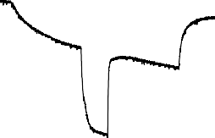

100 s

200 nA

-200

-400

Current (nA)

-600

-800

-1,000

types of painful stimuli: thermal and chemical.

The cloning of VR1 demonstrates unequivocally that the mole- cular target of capsaicin action on sensory neurons is a proteina- cious ion channel. VR1 is structurally related to the TRP family of ion channels that have been proposed to mediate the influx of extracellular calcium in response to depletion of intracellular calcium stores. The precise physiological roles and mechanisms of activation of these channels have been the subject of much debate34. It has been proposed that these channels are gated by diffusible small molecules released from depleted intracellular calcium stores, or

Figure 8 Hydrogen ions potentiate the effect of capsaicin on VR1. a, Augmenta- tion of capsaicin-evoked current response by reduced pH in VR1-expressing oocytes. Capsaicin (cap, 0.3 µM) was administered throughout the time period spanned by the arrows. The pH of the bath solution was changed during the experiment as indicated by the horizontal bars. VR1-expressing oocytes exhibited no responses to pH 6.3 bath solution without capsaicin; water-injected control oocytes exhibited no responses to either capsaicin or pH 6.3 bath solution (not shown). b, Summary of current responses obtained from 9 independent VR1- expressing oocytes. The grey portion of each bar indicates peak current evoked by capsaicin at pH 7.6; the black portion represents the additional current evoked by changing the pH to 6.3.

alternatively that gating involves direct allosteric interactions with store-associated proteins. If TRP-related channels are gated by diffusible molecules, these molecules might bind to a site analogous to that used by vanilloid compounds to activate VR1. Indeed, SKF 96365, an inhibitor of depletion-mediated calcium entry, contains two methoxyphenyl moieties36, which resemble vanillyl groups. An understanding of VR1 activation may therefore provide new molecular insights into these broader biochemical issues. In any case, the distant but clear molecular relationship between VR1 and TRP family members makes it likely that this group of ion channels subserves diverse physiological functions.

The cloned capsaicin receptor is activated not only by vanilloid compounds but also by thermal stimuli within the noxious tem- perature range. The temperature–response profile of VR1 matches very closely those reported for heat-evoked pain responses in humans and animals, and for heat-evoked currents in cultured sensory neurons1,42,43. Several other properties of VR1-mediated heat responses are like those seen in whole animals or in cultured sensory neurons. For instance, ruthenium red, which blocks VR1 activity in mammalian cells or oocytes, also blocks heat-evoked nociceptive responses in the rabbit ear44. In addition, the heat- evoked currents observed in both VR1-expressing cells and cultured sensory neurons are carried through outwardly rectifying, non- selective cation channels42,43. Electrophysiological recordings from cultured sensory neurons reveal a striking concordance between responsiveness to capsaicin and heat45. Our findings, together with these observations, suggest that an *in vivo* role of vanilloid receptors is to detect noxious heat. But not all characteristics of endogenous heat responses resemble those mediated by VR1. In the whole animal, capsaicin pretreatment reduces responsiveness to noxious thermal stimuli in some, but not all, physiological contexts2,3,5. Similarly, in cultured sensory neurons, some heat-activated currents are reported to be insensitive to ruthenium red and to exhibit a lower relative contribution from calcium ions42,43. Thus responses to noxious thermal stimuli may be transduced through multiple molecular pathways, only some of which may involve VR1. It is presently unclear whether thermosensitivity is an intrinsic physical property of VR1, but the fact that VR1 confers heat responsiveness to both mammalian cells and frog oocytes indicates that any other requisite component(s) must be widely expressed. Disruption of the VR1 gene in mice should help to clarify these issues.



The activation of VR1 by heat does not exclude the possibility that small molecules or other endogenous factors also modulate vanilloid-receptor function. It has been proposed, for instance, that protons produce pain by activating vanilloid receptors38. Although we did not observe consistent activation of VR1 by protons alone, we did find that protons can potentiate vanilloid-evoked responses in VR1-expressing oocytes. This is consistent with the observation that hydrogen ions potentiate the effects of low concentrations of capsaicin on cultured sensory neurons39,40. Moreover, in preliminary experiments, we have observed that low pH can also increase the response of VR1 to noxious thermal stimuli in the oocyte expression system. Thus the increased response to noxious stimuli (hyper- algesia) that accompanies inflammation and ischaemia might result, in part, from an enhancement of vanilloid receptor function by the excess hydrogen ions they produce38. If this is the case, VR1 could provide an important model system for the *in vitro* study of hyperalgesia.

The multiple consequences of vanilloid receptor activation make it possible that this protein is involved in diverse human disease states ranging from congenital pain insensitivity to chronic pain syndromes. The cloning of VR1 provides both a molecular probe with which to address these possibilities and a defined target for the development of new analgesic agents. 口

. . . . . . . . . . . . . . . . . . . . . . . . . . . . . . . . . . . . . . . . . . . . . . . . . . . . . . . . . . . . . . . . . . . . . . . . . . . . . . . . . . . . . . . . . . . . . . . . . . . . . . . . . . . . . . . . . . . . . . . . .

Methods

Expression cloning and DNA analysis. A rodent dorsal root ganglion plasmid cDNA library was constructed in pCDNA3 (Invitrogen) essentially as described46, using a mixture of polyadenylated RNA from newborn rat and adult mouse dorsal root ganglia to generate first-strand cDNA. The resulting 2:4 x 106 independent bacterial clones were divided into 144 pools. HEK293 cells expressing the SV40 large Tantigen (gift from T. Livelli) and maintained in DMEM (supplemented with 10% fetal bovine serum (Hyclone), penicillin, streptomycin and L-glutamine) were transfected with plasmid DNA from individual pools using a calcium phosphate precipitation kit (Specialty Media). The next day the cells were replated onto eight-well polyornithine- coated chambered coverglasses (Applied Scientific). Between 6 and 24 h later they were loaded with Fura-2 (30 min at 37 °C) in CIB buffer containing (in

mM) 130 NaCl, 3 KCl, 2.5 CaCl2, 0.6 MgCl2, 1.2 NaHCO3, 10 glucose, 10

HEPES, pH 7.45, with 10 µM Fura-2 acetoxymethyl ester and 0.02% pleuronic acid (Molecular Probes), then rinsed twice with CIB. Ratiometric calcium imaging was performed using a Nikon Diaphot fluorescence microscope equipped with a variable filter wheel (Sutter Instruments) and an intensified CCD camera (Hamamatsu). Dual images (340 and 380 nm excitation, 510 nm emission) were collected and pseudocolour ratiometric images monitored during the experiment (Metafluor software, Universal Imaging). Cells were initially imaged in 200 µl CIB, after which 200 µl CIB containing capsaicin at twice the desired concentration was added. After stimulation, cells were observed for 60–120 s. For each library pool, one microscopic field (300–500 cells) was assayed in each of eight wells. DNA sequencing was performed using an automated sequencer (ABI). Homology searches were performed against the non-redundant Genbank database and against an EST database (dbEST). Hydrophilicity was calculated using the Hopp–Woods algorithm47. VR1 was determined to be of rat origin by sequencing an independent cDNA isolated from a rat dorsal root ganglia library and a polymerase chain reaction (PCR) product derived from mouse dorsal root ganglia.

Oocyte electrophysiology. cRNA transcripts were synthesized from *Not*1- linearized VR1 cDNA templates using T7 RNA polymerase46. Defolliculated *Xenopus laevis* oocytes were injected with 0.5–5 ng VR1 cRNA. Four to seven days after injection, two-electrode voltage-clamp recording was performed (*E*hold ¼ — 60 mV for IC50 curve and thermal stimulation experiments, and  40 mV for all other experiments) using a Geneclamp 500 amplifier (Axon Instruments) and a MacLab A/D converter (Maclab). The recording chamber was perfused at a rate of 2 ml min1 with frog Ringer’s solution containing (in mM) 90 NaCl, 1.0 KCl, 2.4 NaHCO3, 0.1 BaCl2, 1.0 MgCl2 and 10 HEPES, pH

7.6, at room temperature. CaCl2 (2 mM) was used instead of BaCl2 when generating the capsazepine inhibition curve. Thermal stimuli were applied using a preheated bath solution and temperature was monitored using a thermistor placed next to the oocyte. For store-operated current assays, oocytes were incubated for 1–2 h in calcium-free, barium-free frog Ringer’s solution containing 1 mM EGTA and 1 µM thampsigargin. During voltage-clamp recording, these oocytes were intermittently exposed to frog Ringer’s solution containing 2 mM Ca2+ and no EGTA to detect calcium-dependent currents (15- s pulses at 2-min intervals)35. Capsazepine, ruthenium red and thapsigargin were purchased from RBI, SKF 96365 from ICN, and all other chemicals from Sigma. Finely chopped whole peppers (15 g) were extracted overnight at room temperature with 50 ml absolute ethanol. Soluble extracts were concentrated 15-fold by vacuum desiccation, then diluted 1,000-fold in frog Ringer’s solution for electrophysiological assay.

Mammalian cell electrophysiology. Patch-clamp recordings were performed with transiently transfected HEK293 cells at 22 °C. Standard bath solution for whole-cell recordings contained (in mM) 140 NaCl, 5 KCl, 2 MgCl2, 2 CaCl2, 10 HEPES, 10 glucose, pH 7.4 (adjusted with NaOH). In calcium-free bath solution, CaCl2 was replaced with 5 mM EGTA. For monovalent cation substitution experiments, after the whole-cell configuration was obtained in standard both solution, the bath solution was changed to (in mM) 140 NaCl (or KCl or CsCl), 10 glucose and 10 HEPES (adjusted to pH 7.4 with NaOH, KOH or CsOH, respectively) and the reversal potential measured using voltage ramps (see Fig. 3 legend). For divalent cation permeability experiments, the bath solution was changed to (in mM) 110 MgCl2 (or CaCl2), 2 Mg(OH)2 (or Ca(OH)2), 10 glucose, 10 HEPES, pH 7.4 (adjusted with HCl). Bath solution for outside-out patch recordings and pipette solution for inside-out patch recordings contained (in mM) 140 NaCl, 10 HEPES, pH 7.4 (adjusted with NaOH). Bath solution for inside-out patch recordings and pipette solutions for outside-out patch recordings and ion substitution experiments contained (in mM) 140 NaCl, 10 HEPES, 5 EGTA, pH 7.4 (adjusted with NaOH). Pipette solution for other whole-cell recordings contained (in mM) 140 CsCl (or 130 CsAspartate and 10 NaCl), 5 EGTA, 10 HEPES, pH 7.4 (adjusted with CsOH). Liquid junction potentials were measured directly in separate experiments; they did not exceed 3 mV with solutions used and no correction for this offset was made. Whole-cell recording data were sampled at 20 kHz and filtered at 5 kHz for analysis (Axopatch 200 amplifier with pCLAMP software, Axon Instruments). Single-channel recording data were sampled at 10 kHz and filtered at 1 kHz. Permeability ratios for monovalent cations to Na (*P*X/*P*Na) were calculated as follows: *P*X =*P*Na ¼ expð*DV* rev *F*=*RT*Þ, where *V*rev is the reversal

potential, *F* is Faraday’s constant, *R* is the universal gas constant, and *T* is absolute temperature. For measurements of divalent permeability, *P*Y/*P*Na was calculated as follows: *P*Y =*P*Na ¼ ½Naþÿi expð*DV* rev *F*=*RT*Þð1 þ expð*DV* rev *F*=*RT*ÞÞ= 4½Y2þÿO (ref. 48), where the bracketed terms are activities. Assumed ion activity coefficients are 0.75 for monovalents and 0.25 for divalents48.

Cell death, northern blot, and *in situ* hybridization analyses. For cell death assays, HEK293 cells were transfected as described above. Cells were rinsed twice with PBS 14 h later and re-fed with medium containing either capsaicin (3 µM) or vehicle alone (ethanol, 0.3% final). After 7 h, cells were collected and the number of dead cells quantified with an ethidium homodimer and a calcein green-containing cell viability kit (Molecular Probes). For northern analysis, rat-derived poly(A)+ RNA was purified as described49 or with the FastTrack kit (Invitrogen). Approximately 2 µg of each sample was electrophoresed through a 0.8% agarose-formaldehyde gel, transferred to a nylon membrane (Hybond N, Amersham), and hybridized at high stringency with a 32P-labelled probe representing the entire VR1 cDNA. For *in situ* hybridization histochemistry, adult female Sprague-Dawley rats were anaesthetized and perfused with 4% paraformaldehyde in PBS. Tissues were dissected, frozen in liquid N2 and embedded in OCT mounting medium. Cryostat sections (15 µm thick) were processed and probed with a digoxigenin-labelled cRNA generated by *in vitro* transcription of a 1-kb fragment of the VR1 cDNA (nucleotides 1513–2482) (Genius kit, Boehringer Mannheim). Sections were developed with alkaline phosphatase-conjugated anti-digoxigenin Fab fragments according to the manufacturer’s instructions.



Received 20 August; accepted 24 September 1997.

1. Fields, H. L. *Pain* (McGraw-Hill, New York, 1987).
2. Szolcsanyi, J. in *Capsaicin in the Study of Pain* (ed. Wood, J.) 1–26 (Academic, London, 1993).
3. Campbell, E. in *Capsaicin and the Study of Pain* (ed. Wood, J.) 255–272 (Academic, London, 1993).
4. Szallasi, A. & Blumberg, P. M. Vanilloid receptors: new insights enhance potential as a therapeutic target. *Pain* **68,** 195–208 (1996).
5. Jancso, G., Kiraly, E. & Jancso-Gabor, A. Pharmacologically induced selective degeneration of chemosensitive primary sensory neurons. *Nature* **270,** 741–743 (1977).
6. James, I. F., Ninkina, N. N. & Wood, J. N. in *Capsaicin in the Study of Pain* (ed. Wood, J. N.) 83–104 (Academic, London, 1993).
7. Bevan, S. & Szolcsanyi, J. Sensory neuron-specific actions of capsaicin: mechanisms and applications.

*Trends Pharmacol. Sci.* **11,** 330–333 (1990).

1. Oh, U., Hwang, S. W. & Kim, D. Capsaicin activates a nonselective cation channel in cultured neonatal rat dorsal root ganglion neurons. *J. Neurosci.* **16,** 1659–1667 (1996).
2. Wood, J. N. *et al*. Capsaicin-induced ion fluxes in dorsal root ganglion cells in culture. *J. Neurosci.* **8,**

3208–3220 (1988).

1. Feigin, A. M., Aaronov, E. V., Bryant, B. P., Teeter, J. H. & Brand, J. G. Capsaicin and its analogs induce ion channels in planar lipid bilayers. *Neuroreport* **6,** 2134–2136 (1995).
2. Szolcsanyi, J. & Jancso-Gabor, A. Sensor effects of capsaicin congeners I. Relationship between chemical structure and pain-producing potency of pungent agents. *Drug Res.* **25,** 1877–1881 (1975).
3. Szolcsanyi, J. & Jancso-Gabor, A. Sensory effects of capsaicin congeners II. Importance of chemical structure and pungency in desensitizing activity of capsaicin-like compounds. *Drug Res.* **26,** 33–37 (1976).
4. Bevan, S. *et al*. Capsazepine: a competitive antagonist of the sensory neuron excitant capsaicin. *Br. J. Pharmacol.* **107,** 544–552 (1992).
5. deVries, D. J. & Blumberg, P. M. Thermoregulatory effects of resiniferatoxin in the mouse: comparison with capsaicin. *Life Sci.* **44,** 711–715 (1989).
6. Szallasi, A. & Blumberg, P. M. Resiniferatoxin, a phorbol-related diterpene, acts as an ultrapotent analog of capsaicin, the irritant constituent in red pepper. *Neuroscience* **30,** 515–520 (1989).
7. Szallasi, A. The vanilloid (capsaicin) receptor: Receptor types and species specificity. *Gen. Pharmacol.*

**25,** 223–243 (1994).

1. Dray, A., Forbes, C. A. & Burgess, G. M. Ruthenium red blocks the capsaicin-induced increase in intracellular calcium and activation of membrane currents in sensory neurones as well as the activation of peripheral nociceptors in vitro. *Neurosci. Lett.* **110,** 52–59 (1990).
2. Tsien, R. Y. Fluorescent probes of cell signaling. *Annu. Rev. Neurosci.* **12,** 227–253 (1989).
3. Winter, J., Dray, A., Wood, J. N., Yeats, J. C. & Bevan, S. Cellular mechanism of action of resiniferatoxin: a potent sensory neuron excitotoxin. *Brain Res.* **520,** 131–140 (1990).
4. Liu, L. & Simon, S. A. A rapid capsaicin-activated current in rat trigeminal ganglion neurons. *Proc. Natl Acad. Sci. USA* **91,** 738–741 (1994).
5. Scoville, W. Note on capsicums. *J. Am. Pharm. Assoc.* **1,** 453–454 (1912).
6. Woodbury, J. E. Determination of capsicum pungency by high pressure liquid chromatography and spectrofluorometric determination. *J. Assoc. Official Anal. Chem.* **63,** 556–558 (1980).
7. Berkley, R. & Jacobson, E. *Peppers: A Cookbook* (Simon and Schuster, New York, 1992).
8. Mayer, M. L. & Westbrook, G. L. Permeation and block of N-methyl-D-aspartic acid receptor channels by divalent cations in mouse cultured central neurons. *J. Physiol. (Lond.)* **394,** 501–527 (1987).
9. Seguela, P., Wadiche, J., Dineley-Miller, K., Dani, J. A. & Patrick J. W. Molecular cloning, functional properties, and distribution of rat brain a7: a nicotinic cation channel highly permeable to calcium. *J. Neurosci.* **13,** 596–604 (1993).
10. Yeats, J. C., Docherty, R. J. & Bevan, S. Calcium-dependent and -independent desensitization of capsaicin-evoked responses in voltage-clamped adult rat dorsal root ganglion (DRG) neurones in culture. *J. Physiol. (Lond.)* **446,** 390*P* (1992).
11. Holzer, P. Capsaicin: Cellular targets, mechanisms of action, and selectivity for thin sensory neurons.

*Pharmacol. Rev.* **43,** 143–201 (1991).

1. Forbes, C. A. & Bevan, S. Single channels activated by capsaicin in patches of membrane from adult rat sensory neurones in culture. *Neurosci. Lett.* (suppl.) **32,** S3 (1988).
2. Crem, R. J., Fechheimer, M. & MIller, L. K. Prevention of apoptosis by a Bacculovirus gene during infection of insect cells. *Science* **254,** 1388–1390 (1991).
3. Choi, D. W. Glutamate receptors and the induction of excitotoxic neuronal death. *Prog. Brain Res.*

**100,** 47–51 (1994).

1. Hong, K. & Driscoll, M. A transmembrane domain of the putative channel subunit MEC-4 influences mechanotransduction and neurodegeneration in *C. elegans*. *Nature* **367,** 470–473 (1994).
2. Montell, C. & Rubin, G. M. Molecular characterization of the *Drosophila trp* locus: A putative integral membrane protein required for phototransduction. *Neuron* **2,** 1313–1323 (1989).
3. Hardie, R. C. & Minke, B. Novel Ca2+ channels underlying transduction in *Drosophila* photoreceptors: implications for phosphoinositide-mediated Ca2+ mobilization. *Trends Neurosci.* **16,** 371–376 (1993).
4. Clapham, D. E. TRP is cracked, but is CRAC TRP? *Neuron* **16,** 1069–1072 (1996).
5. Petersen, C. C. H., Berridge, M. J., Borgese, M. F. & Bennett, D. L. Putative capacitative calcium entry channels: expression of *Drosophila* trp and evidence for the existence of vertebrate homologs. *Biochem. J.* **311,** 41–44 (1995).
6. Merritt, J. E. *et al*. SK&F 96365, a novel inhibitor of receptor-mediated calcium entry. *Biochem. J.* **271,**

515–522 (1990).

1. Satinoff, E. Behavioral thermoregulation in response to local cooling of the rat brain. *Am. J. Physiol.*

**206,** 1389–1394 (1964).

1. Bevan, S. & Geppetti, P. Protons: small stimulants of capsaicin-sensitive sensory nerves. *Trends Neurosci.* **17,** 509–512 (1994).
2. Petersen, M. & LaMotte, R. H. Effect of protons on the inward current evoked by capsaicin in isolated dorsal root ganglion cells. *Pain* **54,** 37–42 (1993).
3. Kress, M., Fetzer, S., Reeh, P. W. & Vyklicky, L. Low pH facilitates capsaicin responses in isolated sensory neurons of the rat. *Neurosci. Lett.* **211,** 5–8 (1996).
4. Snyder, S. H. Opiate receptors and internal opiates. *Sci. Am.* **236,** 44–56 (1977).
5. Cesare, P. & McNaughton, P. A novel heat-activated current in nociceptive neurons and its sensitization by bradykinin. *Proc. Natl Acad. Sci. USA* **93,** 15435–15439 (1996).
6. Reichling, D. B. & Levine, J. D. Heat transduction in rat sensory neurons by calcium-dependent activation of a cation channel. *Proc. Natl Acad. Sci. USA* **94,** 7006–7011 (1997).
7. Amann, R., Donnerer, J. & Lembeck, F. Activation of primary afferent neurons by thermal stimulation: influence of Ruthenium Red. *Naunyn Schmiedeberg’s Arch. Pharmacol.* **341,** 108–113 (1990).
8. Kirschstein, T., Busselberg, D. & Treede, R. D. Coexpression of heat-evoked and capsaicin-evoked inward currents in acutely dissociated rat dorsal root ganglion neurons. *Neurosci. Lett.* **231,** 33–36 (1997).
9. Brake, A., Wagenbach, M. J. & Julius, D. New structural motif for ligand-gated ion channels defined by an ionotropic ATP receptor. *Nature* **371,** 519–523 (1994).
10. Hopp, T. P. & Woods, K. R. Prediction of protein antigenic determinants from amino acid sequences.

*Proc. Natl Acad. Sci. USA* **78,** 3824–3828 (1981).

1. Valera, S. *et al*. A new class of ligand-gated ion channel defined by P2X receptor for extracellular ATP.

*Nature* **371,** 516–519 (1994).

1. Cathala, G. *et al*. Laboratory methods: A method for isolation of intact, translationally active ribonucleic acid. *DNA* **2,** 329–335 (1983).

**Acknowledgements.** We thank H. Kong, M. Chao and A. Brake for the dorsal root ganglian cDNA and plasmid DNA used in library construction; T. Livelli for HEK293 cells and advice regarding transfection;

J. Trafton for guidance with calcium imaging proceudres; N. Guy for tissue sections; J. Poblete for technical assistance; A. Basbaum and M. Dallman for comments on the manuscript; and A. Brake and

H. Ingraham for advice and encouragement. M.J.C. is a recipient of an American Cancer Society postdoctoral fellowship and a NARSAD young investigator award. This work was supported by grants from the NIH.

Correspondence and requests for materials should be made to D.J. (e-mail: julius@socrates.ucsf.edu). The Genbank accession number for VR1 is AF029310.